
LOAN INVESTMENT MEMORANDUM
161 N. Coit St, Florence, SC 29501

Transaction Overview
Castellan Capital will provide a loan of $19,250,000 to finance the construction of a multifamily property located at 161 N. Coit Street in Florence, South Carolina. Upon completion, the property will span 121,460 gross square feet and 111,209 net rentable square feet across 102 units. The unit mix will consist of 45 one-bedroom units, 41 two-bedroom units, and 16 three-bedroom units. Castellan’s fully funded loan amount represents 60% LTC based on the budgeted project costs. Upon stabilization of the property, the borrower intends to repay Castellan’s loan with permanent financing.
Sponsorship Overview
- Business background: The Borrowers, David and Robert Casselman, have decades of experience across real estate development, finance, and business operations. David Casselman spent over 50 years in financial leadership roles across multinational corporations and entrepreneurial ventures. He has led eight commercial real estate financings ranging from $4.0 million to $75.0 million. Robert Casselman began investing in real estate in the 1960s while working as an accountant. He eventually transitioned into a full-time real estate developer and manager. Notable projects include the Mankato Student Housing portfolio (524 units), All American Self Storage (multiple locations in MN), and The Roseberry, a 285-unit Class A multifamily acquisition in Columbia, SC. Together, David and Robert have demonstrated a strong track record in sourcing, structuring, operating, and refinancing complex real estate transactions across asset types and capital structures.
The General Contractor for the project is Weaver Cook Construction, an industry leading builder specializing in multifamily projects across the Southeast. Founded in 1939 and headquartered in Greensboro, NC, the firm has built a strong reputation for quality, reliability, and collaborative project delivery.
- Personal financials: According to the personal financial statements submitted to Castellan, Robert Casselman has an estimated net worth of $37.21 million, which includes $5.35 million in cash and $32.30 million in real estate assets. David Casselman has an estimated net worth of $8.68 million, which includes $2.39 million in cash and securities and $5.50 million in real estate assets.
- Background & credit check results: Castellan has engaged EagleScreen to perform civil and criminal record checks on David and Robert Casselman. Based on reports, David and Robert have no records of bankruptcy or outstanding judgments, and no civil cases that would impact Castellan’s loan. According to the credit report, David and Robert have credit scores of +794 and +782, with no past due balances on their accounts.

Submarket Overview
The subject property is located at 161 N. Coit Street in the heart of downtown Florence, South Carolina. Centrally positioned across from City Hall and at the corner of West Evans and North Coit Streets, the property sits within walking distance to the McLeod Regional Medical Center, Francis Marion University’s downtown campus, and a vibrant collection of restaurants, shops, art venues, and public gathering spaces. Florence’s population grew by almost 27% between 2009 and 2023. The population has also increased each year since 2001. The city’s median household income is $60,979. Florence has earned recognition as one of America’s Top 50 Cities for Business Relocation and Expansion by Expansion Management Magazine, having attracted over $1.0 billion in capital investment across commercial, institutional, and cultural sectors in the past eight years.
The subject property represents the first phase of a larger master planned redevelopment project that will include a hotel, a 40,000 square foot commercial office building, residential town homes, and the conversion of a historic warehouse to a restaurant/retail center.

Business Plan
Castellan will provide a loan of $19,250,000 to finance the construction of a class-A multifamily property located at 161 N. Coit Street in Florence, South Carolina. The sponsor purchased the 1.33-acre site for $2.04 million and has budgeted $24.79 million in hard costs to construct the property. Upon completion, the property will span 121,460 gross square feet and 111,209 net rentable square feet across 102 units. The building will feature state of the art amenities including a saltwater pool, a full-service fitness center, co-working stations, covered parking, and more. The unit mix will consist of 45 one-bedroom units, 41 two-bedroom units, and 16 three-bedroom units. Castellan’s fully funded loan amount represents 60% LTC based on the budgeted project costs. Upon stabilization of the property, the borrower intends to repay Castellan’s loan with permanent financing.

Risks and Mitigants
LTV Risk: Upon completion of the property, the Loan-to-Value ratio will be approximately 59%, based on the as completed appraised value provided by Integra Realty Resources. Castellan’s independent underwriting and analysis support this valuation. Castellan believes that the strong basis in the loan can facilitate a potential sale of the Note in the event of default. Castellan has developed relationships with defaulted note buyers and has sold several non-performing loans in the past.
Sponsor Risk: Although Castellan has not previously worked with David and Robert Casselman, Castellan performed a background check on the sponsors which revealed no prior defaults, bankruptcies, or liens. A personal guarantee as well as a completion guarantee from the borrower will serve as additional security in the loan.
Construction Completion Risk: Castellan has engaged Partner Engineering and Science to conduct a plan and cost review to independently verify whether the construction budget presented by the sponsor is adequate and sufficient. At the time of this memo, Castellan is awaiting the results of the report. At closing, Castellan will escrow $17,000,000 as a Construction Reserve towards hard costs completed on the project.
Environmental Risk: Castellan engaged CBRE to conduct a Historical Records + Database Review on the property. At the time of this memo, Castellan is awaiting the results of the report.
Interest Rate/Return Risk: The interest rate is floating based on CME 1-Month SOFR and 4.91% and is not capped. The effective rate at closing is expected to be 9.25%. A floor rate of 8.75% is established to provide stability should interest rates decrease. Castellan will hold a $2,250,000 interest reserve.

Insurance Risk: At closing, the property will be covered with general liability coverage of $5,000,000 per occurrence. The sponsor will have a builder’s risk policy with a coverage always amount greater than Castellan’s loan principal. At the time of this memo, the sponsor is working on binding their policies. In reviewing insurance coverage, the firm relies on each of the following: the insurance coverage for similar types of properties in its existing portfolio of loans, and an independent review and recommendation from York International, which is Castellan’s main insurance agent.

Loan Financials
Please see below for an overview of relevant loan metrics and other financial information about the property and transaction:
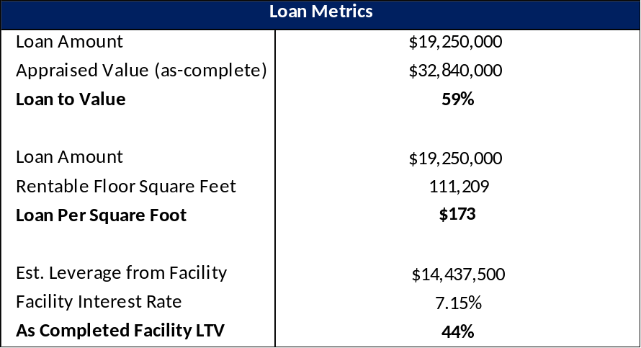
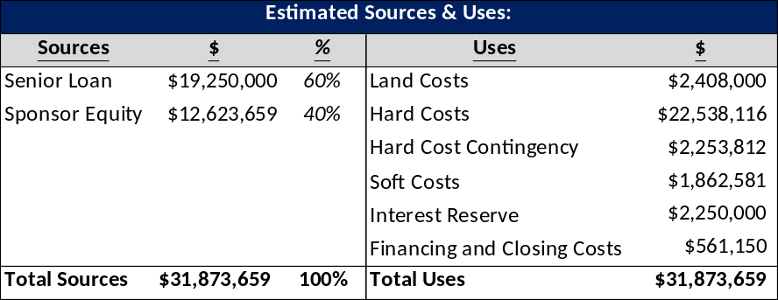
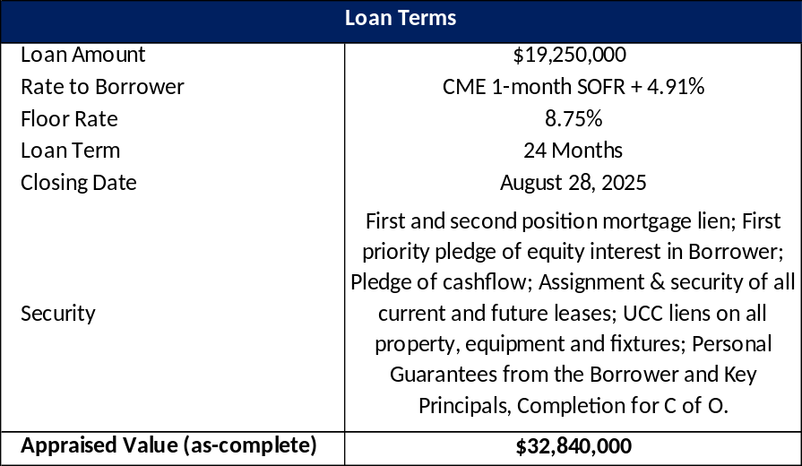
Investment Highlights
Castellan believes this is an attractive investment opportunity for the following reasons:

- This loan presents an attractive risk-adjusted return for a first-lien position in a construction property in Florence, South Carolina.
- Castellan’s fully funded as-complete LTV ratio is approximately 59%.
- The Sponsor has a liquidity of $5MM.
- The sponsor, developer and GC are all experienced with a specialty in the subject submarket.
- The borrower has invested substantial real equity ahead of Castellan’s loan, which will be approximately $12.6MM upon completion and will represent 40% of the project’s total cost.
- In the event the company comes into possession of the collateral, Castellan believes that it would have the potential to foreclose on the property and take title at an attractive overall cost basis. Alternatively, Castellan believes they would be able to sell the note in an event of default as Castellan has relationships with non-performing note buyers.

